This Ashram has been built for you and through you
for the whole of humanity.
Ashram is the mother of science, of true religion; and in the near future it will be the symbol of East-West unity.

May Ananda Ashram be the abode of heaven on earth!

- Shri Brahmananda Sarasvati

Membership is a vital and much respected part of our organization. In appreciation, we offer many benefits which we hope will encourage your further participation.

Membership Application

Name ________________________________________
City___________________State ________ Zip__________
Phone __________________ Cell Phone ________________
Email _______________________________________

Membership Category ________________
Family Members' Names (if applicable) ________ _______________________
Profession or Skills _______________
If we need your help may we call upon you? _____ Total Contribution enclosed _____________
Signature __________ Date _____

Please make your check payable to the Yoga Society of New York, Inc.

Thank you from all Yoga Society members and friends!

The Yoga Society of New York, Inc. is a nonprofit, tax-exempt organization,
501(c)(3). Donations are tax-deductible as permitted by law.

Membership Fees & Benefits
Yearly
- Individual - $125
- Couple or 2 family members - $ 200
- Family of 3 or more - $ 250
One Time
- Lifetime Membership, individual - $ 2,000
Benefits include:
A book by Shri Brahmananda Sarasvati,
an Ashram poster and an Ashram CD.
Plus complimentary accommodations for
one weekend / 2 nights stay per year for the Lifetime member and one guest. Certain weekends may be exempt, please call to inquire.

All Members receive:
- Member discounts for overnight guest rates,
cultural programs and selected workshops.
- 10% discount at the Ashram Gift Shop and at www.ashramSTORE.com.
- Full swimming pool privileges.
To apply for membership, you may call the office at 845.782.5575 or complete this application form and return it to our office with your contribution.
Jul '13

Note: The above refers to non-voting Membership. Inquire about voting privileges pursuant to the By-Laws.

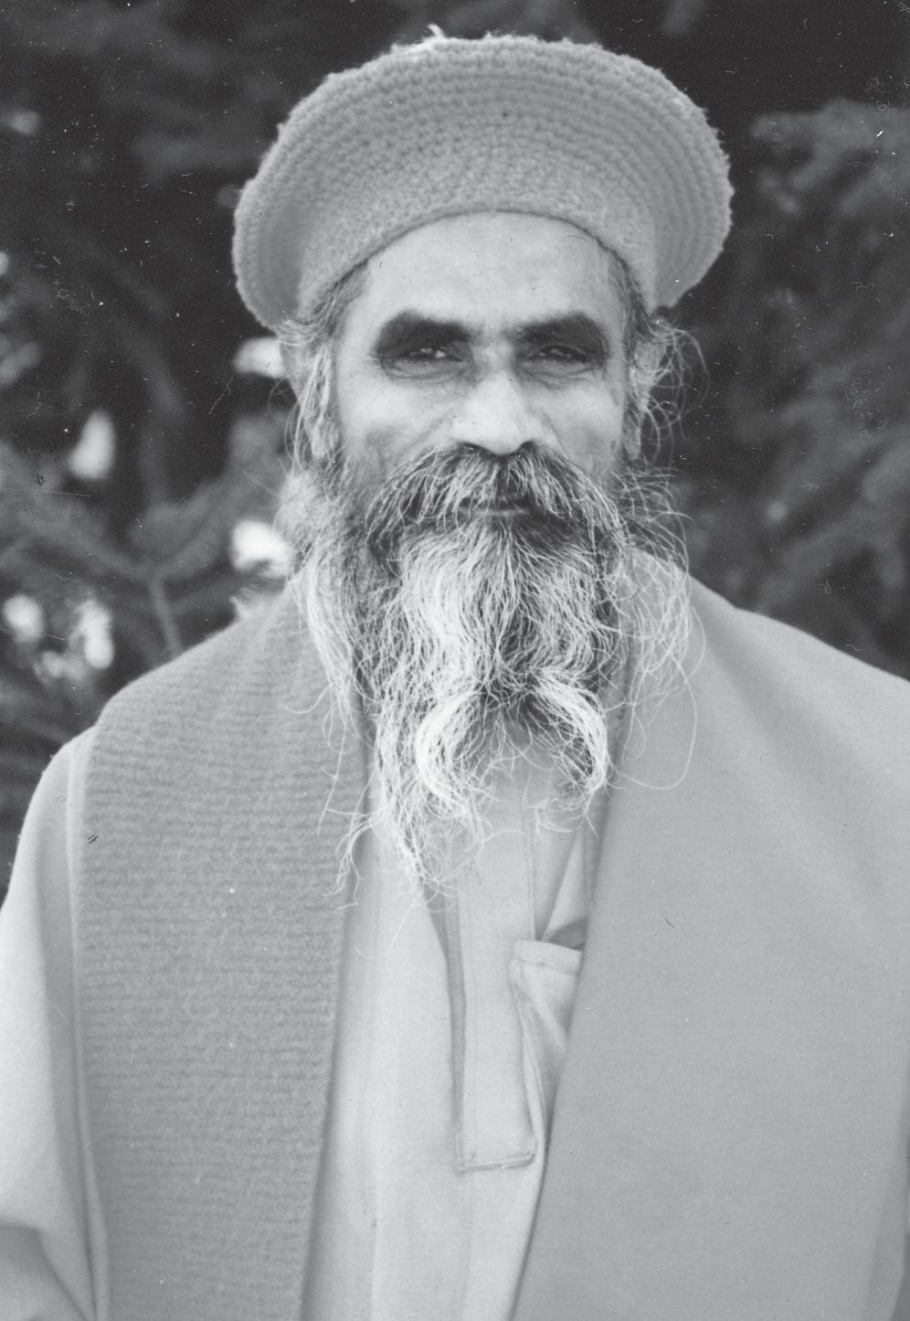





Shri Brahmananda was dedicated to the integration of Eastern
and Western sciences, culture and philosophy, to bring about the full
realization of individual and universal peace and harmony in spiritual
unity. He had an extensive background in Eastern and Western medicine
and was a recognized authority on the science, philosophy and psychology
of Yoga and Vedanta. His writings include Fundamentals of Yoga and
The Textbook of Yoga Psychology. Shri Brahmananda left his body in 1993.
His spiritual presence continues to pervade the Ashram, and his teachings
remain as a source of inspiration and guidance for all.



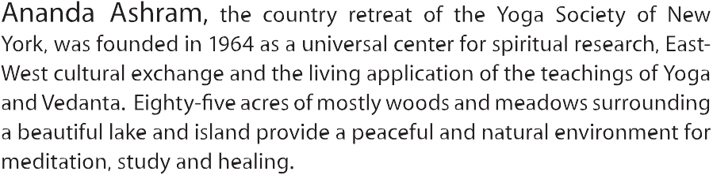



Ananda Ashram

YOGA SOCIETY OF NEW YORK INC. MONROE, NY

